Lab 3

Exercise 1.1 Neo4j temporal analysis using Cypher
LOAD CSV WITH HEADERS FROM
"https://gist.githubusercontent.com/apogiatzis/f7793b9707f3b15f5e811acb4f9d82bb/raw/d5e769a47955fd79ca3b00efd82d48041f883a31/persons.csv" AS
csvLine
MERGE (e:Email {address: csvLine.email})
MERGE (t:Phone {number: csvLine.phone})
CREATE (p:Person {obj_id: csvLine.obj_id, first_name:
csvLine.first_name, last_name: csvLine.last_name, date_of_birth:
date(csvLine.date_of_birth), occupation: csvLine.occupation,
nationality: csvLine.nationality, phone: csvLine.phone, ni_number:
csvLine.ni_number})
CREATE (p)-[:HAS_EMAIL]->(e)
CREATE (p)-[:HAS_PHONE]->(t)

LOAD CSV WITH HEADERS FROM
"https://gist.githubusercontent.com/apogiatzis/ce3572b2671730a95ff2d96e3318764d/raw/e4d29e632f1510594f499608983c475da0143e68/accounts.csv" AS
csvLine
MATCH (p:Person {obj_id: csvLine.owners})
MERGE (b:Bank {name: csvLine.bank})
CREATE (a:Account {obj_id: csvLine.obj_id, balance:
toFloat(csvLine.balance), currency: csvLine.currency, owner:
csvLine.owners, opened_at: datetime(replace(csvLine.opened_at, ' ',
'T'))})
CREATE (p)-[:OWNS]->(a)
CREATE (a)-[:PROVIDED_BY]->(b)

LOAD CSV WITH HEADERS FROM
"https://gist.githubusercontent.com/apogiatzis/e8188df98dbc8810d49f274af7e607ac/raw/c014fc9cdd1d4f024b910af4966a5e2ab5a104f9/transactions.csv"
AS csvLine
MATCH (sender:Account {obj_id: csvLine.sender})
MATCH (recipient:Account {obj_id: csvLine.recipient})
CREATE (t:Transaction:Transfer {obj_id: csvLine.obj_id, amount:
toFloat(csvLine.amount), currency: csvLine.currency, type:
csvLine.type, timestamp: datetime(replace(csvLine.timestamp, ' ',
'T'))})
CREATE (sender)-[:PERFORMED]->(t)
CREATE (t)-[:TO]->(recipient)

LOAD CSV WITH HEADERS FROM
"https://gist.githubusercontent.com/apogiatzis/04addd6990394aec5695d70e020d7ee3/raw/b63b71c0bcd5275e6c31ee7bc9a1944975be8fe2/deposits.csv" AS
csvLine
MATCH (sender:Person {obj_id: csvLine.sender})
MATCH (recipient:Account {obj_id: csvLine.recipient})
CREATE (t:Transaction:Deposit {obj_id: csvLine.obj_id, amount:
toFloat(csvLine.amount), currency: csvLine.currency, type:
csvLine.type, timestamp: datetime(replace(csvLine.timestamp, ' ',
'T'))})
CREATE (sender)-[:PERFORMED]->(t)
CREATE (t)-[:TO]->(recipient)

MATCH (p:Person)-[:PERFORMED]-(d:Deposit)-[:TO]->(a:Account) RETURN p,a,d

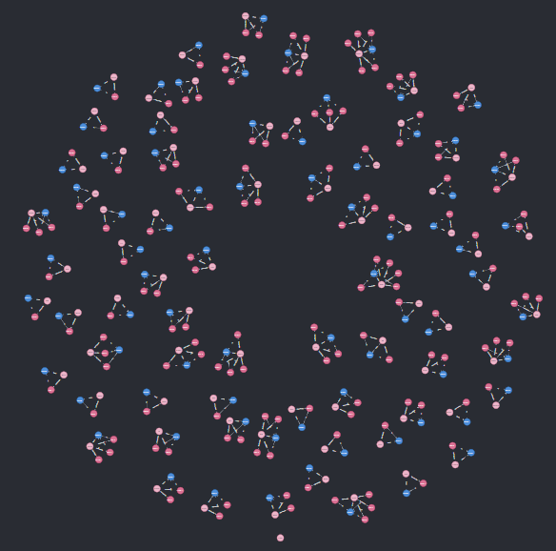
MATCH (p:Person)-[:PERFORMED]-(d:Deposit)-[:TO]->(a:Account)
WITH min(d.timestamp) AS min_date, max(d.timestamp) AS max_date
RETURN min_date, min_date.epochMillis AS min_date_epoch, max_date,
max_date.epochMillis AS max_date_epoch

UNWIND range(880092632000, 1644640280000, 86400000) AS t
MATCH (p:Person)-[:PERFORMED]-(d:Deposit)-[:TO]->(a:Account)
WHERE d.timestamp.epochMillis >= t AND d.timestamp.epochMillis < t +
86400000
RETURN datetime({epochMillis:t}), COUNT(*) as deposit_count ORDER BY
deposit_count desc

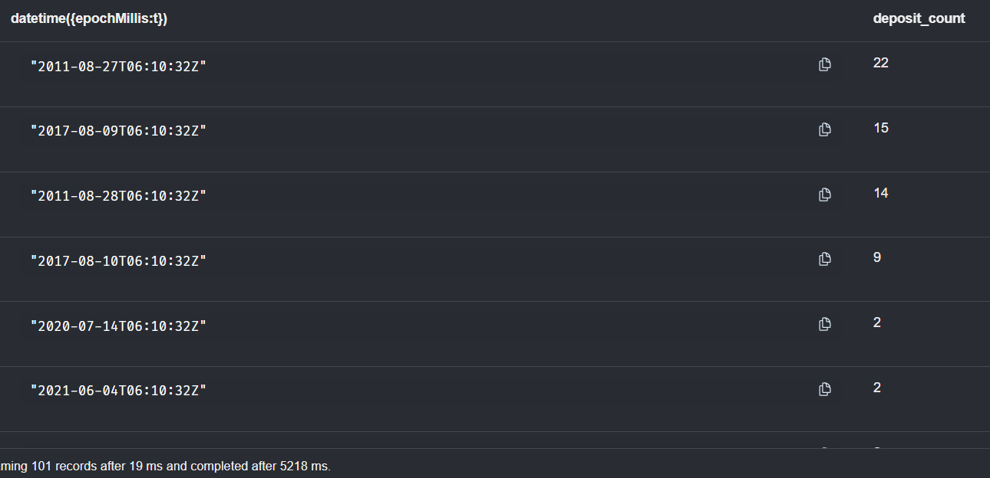
MATCH (p:Person)-[:PERFORMED]-(d:Deposit)-[:TO]->(a:Account)
WITH *,datetime("2011-08-27T06:10:32Z") as window_start
WHERE d.timestamp.epochMillis >= window_start.epochMillis AND
d.timestamp.epochMillis < window_start.epochMillis + 86400000
RETURN p,d,a

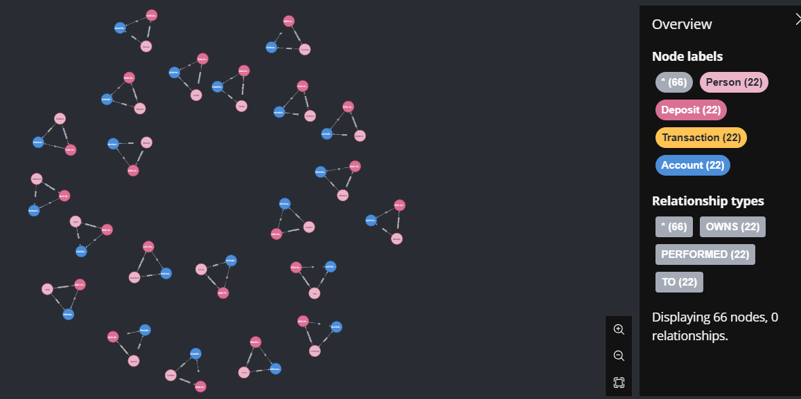
MATCH (p1:Person)-[:HAS_EMAIL|:HAS_PHONE]->(info)<-
[:HAS_EMAIL|:HAS_PHONE]-(p2:Person)
WHERE p1.obj_id<>p2.obj_id
WITH p1, p2, count(*) as cnt
MERGE (p1) - [:SHARED_IDENTIFIERS {count: cnt}] - (p2);

MATCH (p:Person)-[:PERFORMED]-(d:Deposit)-[:TO]->(a:Account)
MATCH (p)-[:SHARED_IDENTIFIERS]-(o:Person)
WITH *,datetime("2011-08-27T06:10:32Z") as window_start
WHERE d.timestamp.epochMillis >= window_start.epochMillis AND
d.timestamp.epochMillis < window_start.epochMillis + 86400000
RETURN p,d,a,o

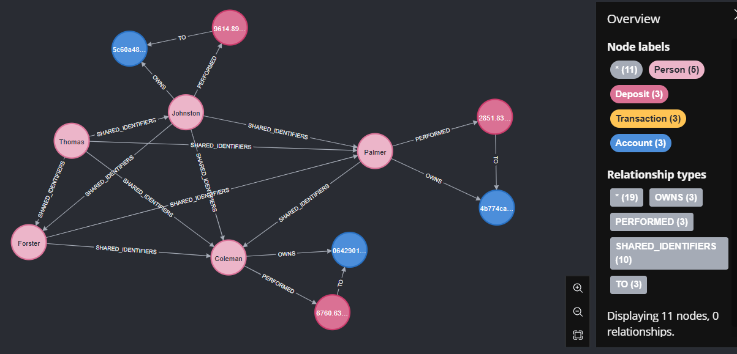

MATCH (p:Person)-[:PERFORMED]-(d:Deposit)-[:TO]->(a:Account)
MATCH (p)-[:SHARED_IDENTIFIERS]-(o:Person)
WITH *,datetime("2011-08-27T06:10:32Z") as window_start
WHERE d.timestamp.epochMillis >= window_start.epochMillis AND
d.timestamp.epochMillis < window_start.epochMillis + 86400000
RETURN d.obj_id

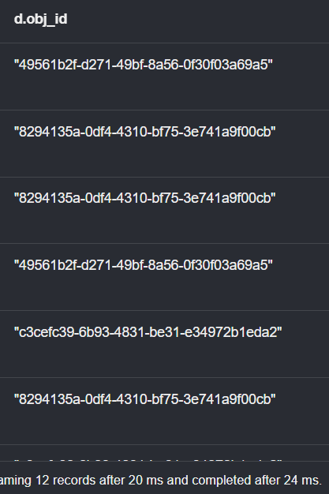
"49561b2f-d271-49bf-8a56-0f30f03a69a5"
"8294135a-0df4-4310-bf75-3e741a9f00cb"
"8294135a-0df4-4310-bf75-3e741a9f00cb"
"49561b2f-d271-49bf-8a56-0f30f03a69a5"
"c3cefc39-6b93-4831-be31-e34972b1eda2"
"8294135a-0df4-4310-bf75-3e741a9f00cb"
"c3cefc39-6b93-4831-be31-e34972b1eda2"
"49561b2f-d271-49bf-8a56-0f30f03a69a5"
"c3cefc39-6b93-4831-be31-e34972b1eda2"
"8294135a-0df4-4310-bf75-3e741a9f00cb"
"49561b2f-d271-49bf-8a56-0f30f03a69a5"
"c3cefc39-6b93-4831-be31-e34972b1eda2"

